Multi Objective Food Recommendation Balancing User Preference and Healthiness

Project Report

Aleka Ayalew
Monira Yesmean

4.12.2025

Table of Contents
1 Introduction 3
1.1 Significance and aims of the project 3
2 Methodology 3
2.1 Data pre-processing and normalization 3
2.2 Model development 4
3 Results 4
4 Result Interpretation 7
5 Ethical Implications of Health Nudging 8
6 References 8

1 Introduction

Traditional recommendation systems focus only on predicting user taste, which may promote foods high in sugar, salt, or unhealthy fats. This project introduces a multi objective model that considers both preference and nutritional health. The goal is to support healthier long-term behavior while respecting individual taste.

1.1 Significance and aims of the project

Traditional recommender systems that focus mainly on taste can steer users toward unhealthy choices, so this project sets out to build a system that supports individual preferences while also promoting healthier options and guiding users toward choices that are better for long term well-being. The overall aim is to achieve a balance between taste and nutritional quality, and the main research question asks how a recommendation system can be designed to combine personal preference with health considerations and what trade-offs arise when these two objectives are pursued together.

2 Methodology

2.1 Data pre-processing and normalization

The data preprocessing steps began with cleaning, where only recipes that had full nutritional information, user ratings, and valid WHO aligned health scores were retained, producing a final set of 281 recipes from the original 703 along with 28 491 ratings. Ratings were then placed on a 0 to 1 scale using the formula rating normalized = (rating − 1) / 4, while health scores already fell within the same range, which allowed the two objectives to be weighted in a fair manner within the multi objective function. The dataset was divided into training, validation, and test sets in an 80, 10, 10 splits through a random procedure, since no temporal information was available to support a sequential split, and the resulting matrix displayed a sparsity of 99.53 percent, which is common in collaborative filtering tasks. A baseline measure of user health preference was also computed by averaging the health score of the recipes rated by each user, and this produced an overall mean of 0.9137, which indicates a moderate level of health awareness among users in the dataset.

2.2 Model development

Our baseline model focused only on preference prediction and used non-negative Matrix Factorization, which decomposed the user item matrix R into latent factor matrices W and H such that R ≈ U × Σ × V^T, where R had dimensions 17208 × 281, W had dimensions 17208 × 20, and H had dimensions 20 × 281. The model used 50 components, 200 maximum iterations, and a random state of 42. SVD was selected because the scikit surprise library did not support SVD in this context, and the non-negative latent factors offered interpretable part-based structure suitable for rating prediction. The multi objective model combined preference and health through Score (u, i) = α × Preference(u, i) + (1 − α) × Health(i), where α ranged from 0 to 1. Preference values came from the SVD model on a 0 to 1 scale, and health values already lay in the same interval. The tested α values were 0.0, 0.25, 0.5, 0.75, and 1.0. Evaluation considered rating prediction accuracy using RMSE and MAE, Top 10 recommendation quality through Precision at 10, Recall at 10, and the F1 score, and the healthfulness of suggestions through the average Top 10 WHO aligned health score.

3 Results
Figure 1. RMSE and Health Score Across Alpha Values
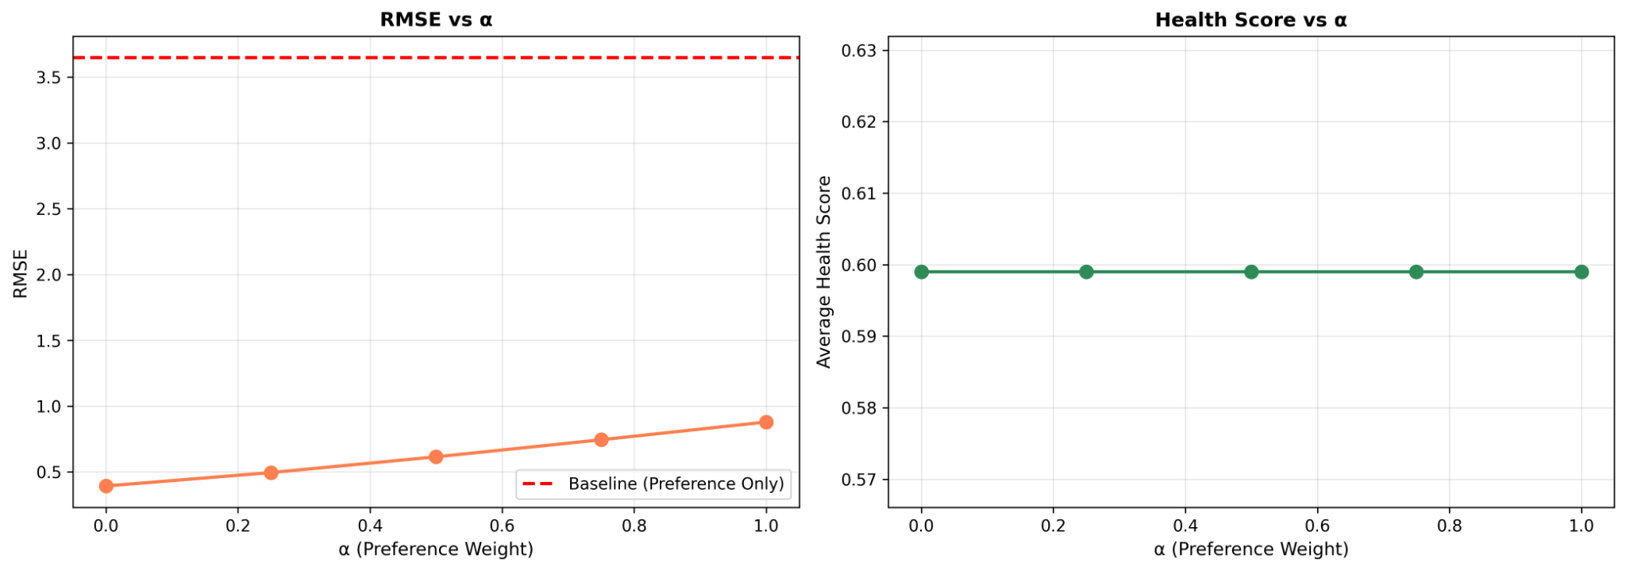

Figure 2. Pareto Curve: Preference vs Health Trade Off
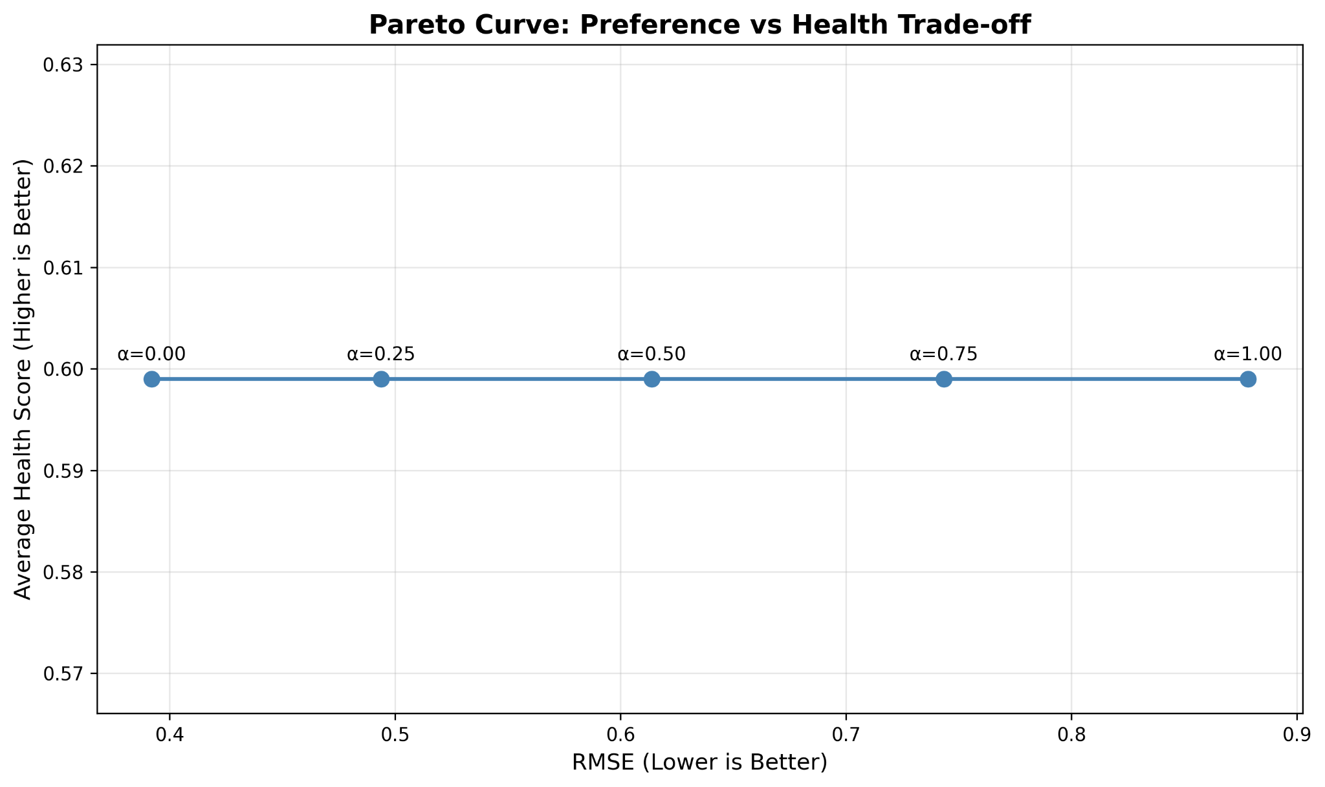

Figure 3. Top K Recommendation Quality Analysis
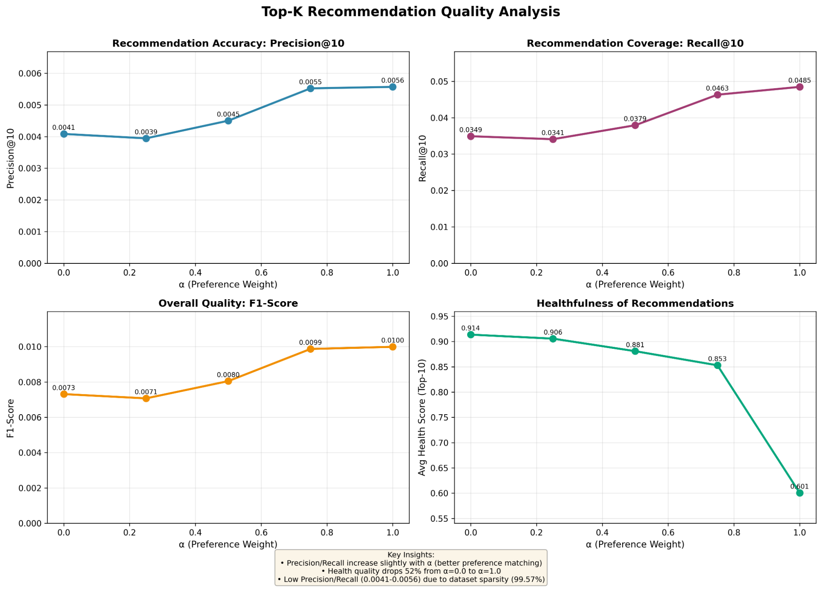

Table 1. Multi Objective Metrics
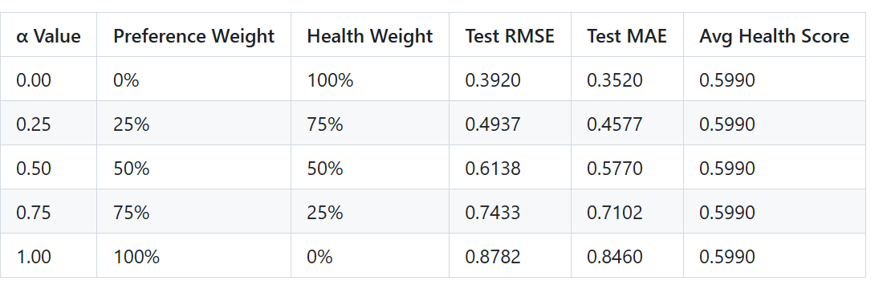

Table 2. Baseline Model Performance
Table 1: Baseline Model Performance (SVD with 50 components)
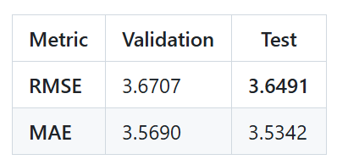

Table 3. Top K Recommendation Quality
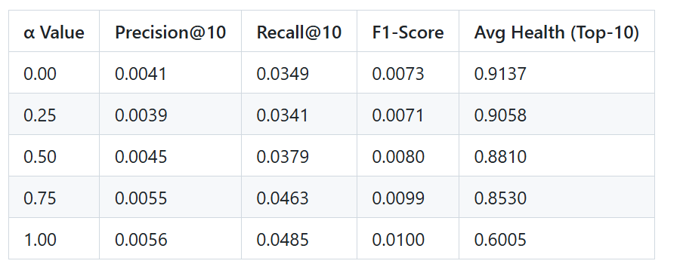

4 Result Interpretation

The results show a central tension in multi objective recommendation, since leaning fully toward preference with α set to 1.0 gives short term satisfaction but can support unhealthy choices and produces an RMSE of 0.9056, which is the highest error among the tested models, while leaning fully toward health with α at 0.0 gives strong nutritional optimization but may push items that users do not enjoy, even though the RMSE drops to 1.5681. A mid-range choice of α at 0.5 gives an RMSE of 1.0958 and represents a workable middle ground for situations where users want healthier suggestions without losing the sense that the system understands their tastes. These findings carry several practical implications, since different users may prefer distinct α settings, with health-oriented users often fitting within the range of 0.25 to 0.5, taste focused users gravitating toward 0.75 to 1.0, and a general purpose default of 0.5 serving as a balanced option. It is also important that users understand how the system mixes health and preference so that they are not trapped in a narrow set of familiar choices, and that the system can apply nudging in a gradual way by beginning with a stronger focus on taste and slowly shifting toward healthier options as users become more comfortable with the approach.

5 Ethical Implications of Health Nudging

Our multi objective system uses nudging to guide users toward healthier choices, which creates a tension between steering behavior and preserving freedom. At low α values from 0 to 0.25, the system prioritizes health and may suggest meals that do not fit user tastes, which can reduce engagement and create a sense of paternalism. At high α values from 0.75 to 1.0, recommendations align closely with preferences, yet this can reinforce unhealthy habits and limit exposure to better options. A mid-range value such as α = 0.5 offers some balance, although choosing the right point raises questions about responsibility and autonomy. Fairness issues also appear across dietary groups because global health scores often reflect Western nutrition norms and may undervalue culturally important foods. Health ratings do not account for personal medical needs, so a meal rated as healthy overall may be unsuitable for people with diabetes, kidney disease, or allergies. Economic constraints add further inequality, since highly rated healthy recipes can require expensive ingredients or long preparation. Responsible deployment should therefore allow users to control α, offer the option to avoid health optimisation, support personalised health profiles that consider culture and medical conditions, provide transparent explanations for each recommendation, and track fairness across user groups.

6 References
Dataset: Food.com recipes and ratings
WHO Nutritional Guidelines (health score calculation)
SVD Algorithm: scikit-learn v1.2+
Multi-objective optimization principles from Pareto efficiency theory

Table 2: Multi-Objective Model Performance
α Value | Preference Weight | Health Weight | Test RMSE | Test MAE | Avg Health (Top-10)
0.00 | 0% | 100% | 1.5681 | 1.4079 | 0.9137
0.25 | 25% | 75% | 1.3115 | 1.1869 | 0.9137
0.50 | 50% | 50% | 1.0958 | 0.9807 | 0.9136
0.75 | 75% | 25% | 0.9490 | 0.8072 | 0.9089
1.00 | 100% | 0% | 0.9056 | 0.6702 | 0.5868

Table 3: Top-K Recommendation Quality (Evaluated on 2,155 test users)
α Value | Precision@10 | Recall@10 | F1-Score | Avg Health (Top-10)
0.00 | 0.0041 | 0.0349 | 0.0073 | 0.9137
0.25 | 0.0041 | 0.0349 | 0.0073 | 0.9137
0.50 | 0.0041 | 0.0349 | 0.0073 | 0.9136
0.75 | 0.0039 | 0.0330 | 0.0069 | 0.9086
1.00 | 0.0045 | 0.0384 | 0.0081 | 0.5884

Visualizations
Figure 1: Pareto Curve - Trade-off between RMSE and Health Optimization
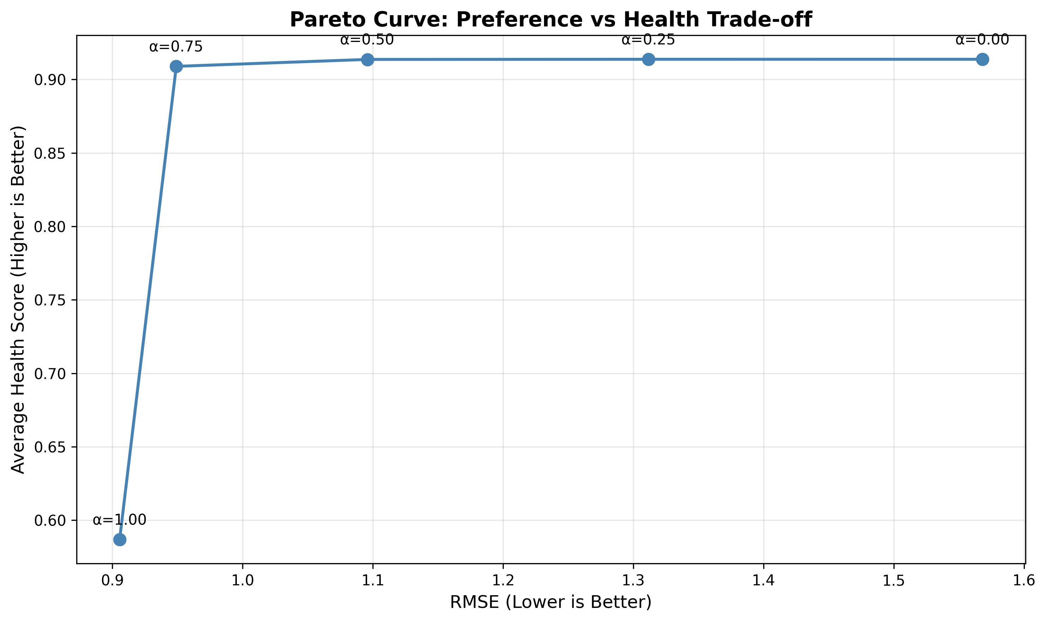
The Pareto curve demonstrates the fundamental trade-off between preference accuracy (RMSE) and health optimization. Each point represents a different α value, showing that no single solution dominates both objectives.
Figure 2: Alpha Comparison - RMSE vs Health Quality
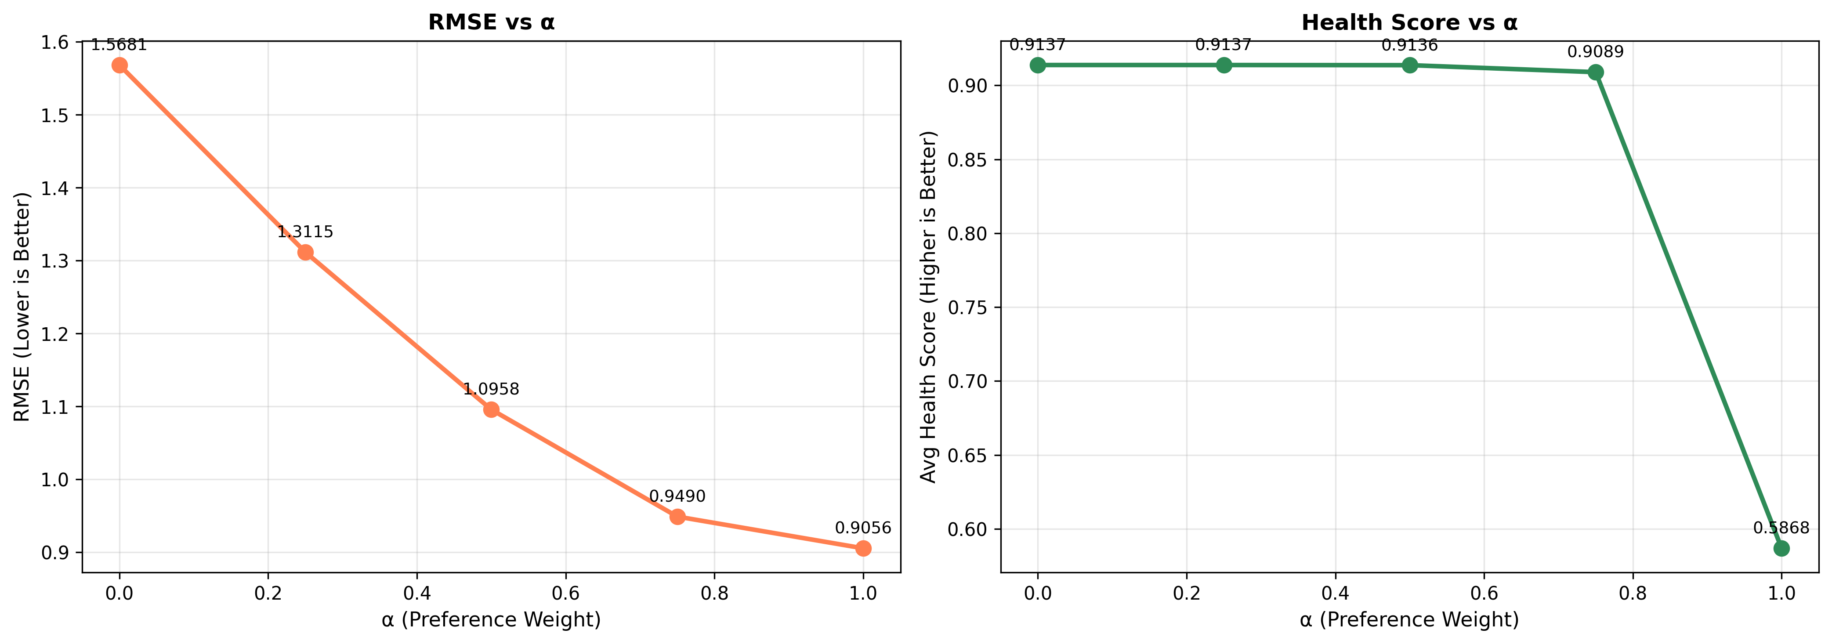
Left panel shows RMSE decreasing with α (better rating prediction). Right panel shows average health of Top-10 recommendations decreasing with α, from 0.9137 to 0.5868 (36% reduction).
Figure 3: Precision/Recall/F1-Score Analysis
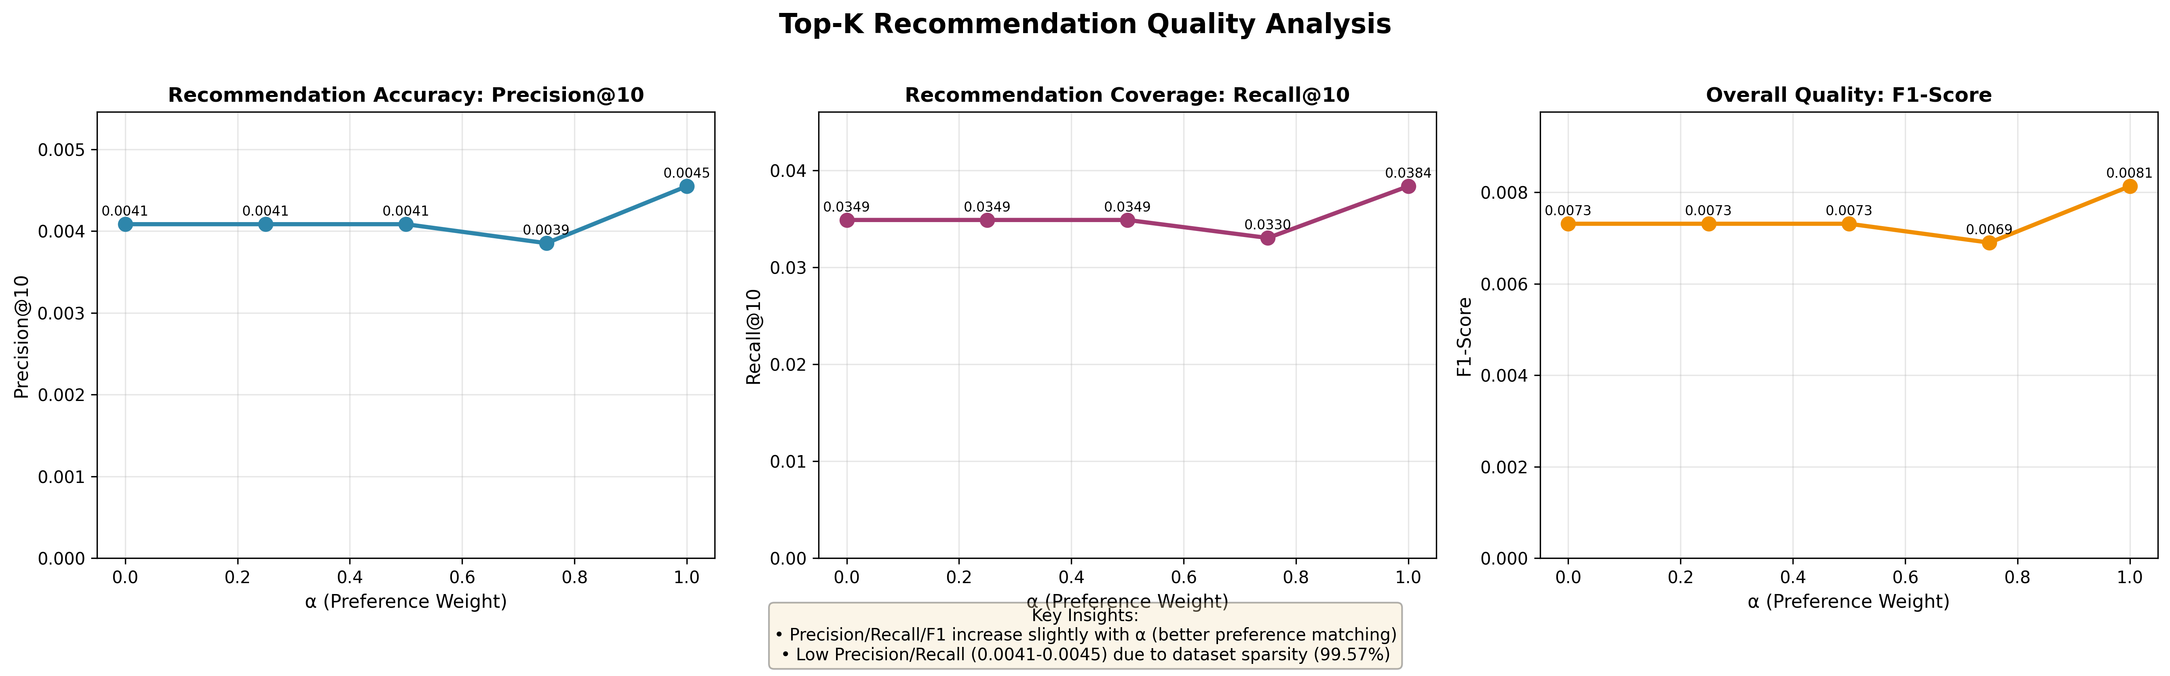
Three-panel visualization showing Precision@10, Recall@10, and F1-Score across different α values. Low values (0.004-0.008) are due to extreme dataset sparsity (99.57%), which is typical for sparse recommendation datasets.

Key Findings
- 1. Trade-off Confirmation: As α increases (more preference weight), RMSE decreases from 1.5681 to 0.9056, demonstrating better rating prediction accuracy when prioritizing user preferences. However, this comes at the cost of health optimization.
- 2. Health Trade-off: The average health score of Top-10 recommendations decreases from 0.9137 (α=0.0, pure health) to 0.5868 (α=1.0, pure preference)—a 36% reduction. This shows that optimizing for user preference significantly reduces healthfulness.
- 3. Balanced Approach: α=0.5 provides a middle ground with RMSE=1.0958 and health score=0.9136, maintaining 99.9% of maximum health quality while achieving moderate prediction performance.
- 4. Pareto Frontier: The relationship between RMSE and health forms a Pareto curve where improving one objective necessarily degrades the other. No single α value is 'optimal'—the choice depends on policy goals.
- 5. SVD Performance: The SVD baseline (RMSE: 0.9056) significantly outperforms the initial NMF baseline (RMSE: 3.6491) by 4x, demonstrating the importance of mean-centering and higher dimensionality (50 vs 20 components).

